PETROL PRICE PREPARED
NOVEMBER 4, 2021
BY SAMANTHA GREATHEAD
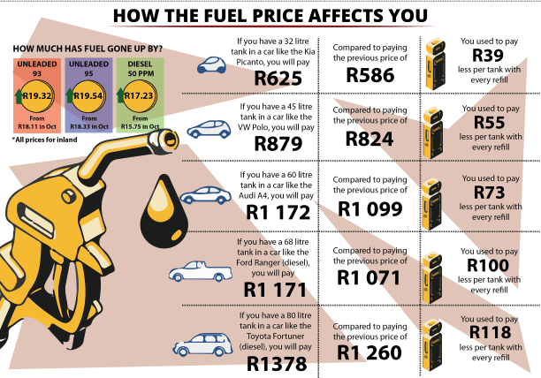

Most South Africans likely woke up to full fuel tanks on Wednesday but the prospect of paying much more for the next tank. At midnight the price of fuel increased by R1.21 for petrol and R1.48 for diesel. That brings the fuel price to just under R20 per litre.

The CEO of MasterDrive, Eugene Herbert, says with this prospect on the horizon motorists need to make a concerted effort to reduce their fuel consumption. “This is one of the most significant petrol price increases South Africa has faced in some time. Whether you’re an individual or a company it is bound to affect your pocket. For companies, it increases the price of delivery which then trickles down to the consumer. Now consumers are paying more for both goods and petrol.

“Consequently, the importance of keeping fuel consumption in mind whenever you drive is essential. MasterDrive is sharing 10 tips to remind South African drivers about reducing fuel consumption as they face these higher petrol prices, especially just before the holiday season as well.”

- Ensure your vehicle’s maintenance is up-to-date. Not replacing certain parts in your car can considerably affect fuel consumption.
- Maintaining an adequate following distance and watching 12 seconds ahead helps save fuel as you have more time to react to traffic. You can then slow down and potentially avoid coming to a complete stop.
- Keeping your revs between 2 500 rpm and 3 500 rpm can reduce your petrol consumption by up to 20%. In diesel vehicles the rpm can be as low as 2 000.
- Something else that can contribute to a 20% reduction is keeping your speed low. Travelling at a reduced speed, where possible, has shown to also play a role in reducing fuel consumption.
- Avoid costly behaviours behind the wheel such as driving aggressively.
- Using your aircon judiciously and making sure that open windows do not add to increased wind resistance will also help.
- Plan your routes. Plenty of petrol can be wasted by not making your route as efficient as possible.
- Avoid driving with unnecessary items in your car that add to the weight of the vehicle.
- Avoid idling for longer than 30 seconds.
- Ensure tyres are properly inflated. Under-inflated tyres increase fuel consumption.
While it is difficult to accurately predict, the outcome for December does not look much better. “Even if we are fortunate enough to see a decrease, the fuel price is still high. Follow these tips to reduce the effect that this has on you or your business as much as possible,” says Herbert.

